instructions for preparing papers for the

NBDC 2019 proceedings

O. Alves-Filho¹, S. Goncharova-Alves²

¹Norwegian University of Science and Technology
Kolbjørn Hejes vei 1b, 7491 Trondheim, Norway, Email: odilio.alves@ntnu.no
²D.I. Mendeleev University of Chemical Technology of Russia
Miusskaya sq. 9, 125047 Moscow, Russia, Email: chemcom@muctr.ru

Keywords: equations, figures, fonts, format, style, tables

ABSTRACT

This is a guideline model for authors preparing papers for NBDC 2019. The instructions in this model should be followed closely for writing and submitting the papers for scientific sessions as well as for plenary and keynote lectures that will be published on the NBDC’s USB-Proceedings.

introduction
The Third Nordic Baltic Drying Conference will be held from 12 to 14 June 2019 in Saint Petersburg, Russia. The papers accepted and presented at the conference will appear in the NBDC's USB-Proceedings having an ISBN number as required for scientific citation, retrieval or order by interested persons, libraries, institutions and companies. Additionally, selected papers will be published in the Reviewed Electronic Journal Chemical Engineering.
All the papers in the USB-Proceedings will encompass search engine to facilitate the access to stored papers based on author's indices and conference's sessions. Besides the USB-Proceedings, each participant of the NBDC 2019 will also receive a book of abstracts.

General rules
The accepted paper will be published without full-review, so it is the author's responsibility to carefully proofread and correct it before final submission. Each paper will be examined and may be rejected if requiring significant rewriting.
The paper for technical or scientific sessions has about 10 pages and plenary or keynote lecture manuscripts may have up to 20 pages.
The typing space per A4 format page is about 170 mm wide and 257 mm high, then all margins are 20 mm.
The paper should be prepared as MS Word document and the basic font is Times New Roman,
12 pt, black and justified. Paragraphs are single-spaced and language is set to English (United States option). The pages are numbered by alignment to right side at the bottom of the page with footer
1 cm and the font is 10 pt Times New Roman. Please, don’t show the number on the first page.
The MS Word document has to be submitted in the conference website https://nbdc.sciforum.net/

First page

Title
The first page of the manuscript starts with the title. Font is Times New Roman, 14 pt, black, bold, capital and centered. The title line(s) should be preceded by 5 blank lines (14 pt).

Author(s)
After the title, the name(s) of the author(s) is (are) typed in Times New Roman font, 14 pt, black and centered. The name(s) of the author(s) should be preceded by 2 blank lines (14 pt). In the author list, the name of the speaker has to be underlined, unless there is only one author. If group of the authors represents different institutions or organizations use the numbers in superscript behind the corresponding author to show relation between author and affiliation.

Affiliation(s)
Next item on the first page of the paper is the affiliation of the author. The affiliation should be preceded by 1 blank line (14 pt). The font of the affiliation line is Times New Roman, 12 pt, black, italic and centered.
In case more than one affiliation has to be entered, please, use numerals in superscript before each institution and leave space of 6 pt between each affiliation.

Keywords
You have to state up to 6 keywords using Times New Roman font, 12 pt, black and centered. The Keywords line has to be preceded by 2 blank lines (12 pt). The keywords have to be arranged alphabetically and separated by commas.

Abstract
Last item on the first page preceding the main text is the abstract. The abstract is typed using Times New Roman font, 12 pt, black and justified. From both sides the abstract text is indented
15 mm relative to the main text.
The title “ABSTRACT” has font 12 pt in capitals and centered. It should be preceded by 2 blank lines (12 pt). The abstract text should be preceded by 1 blank line (12 pt) and limited to a maximum of 15 lines.
The main text should follow immediate after the abstract. Please do not leave the abstract on the front page with only empty space below.

main text

Typographical instructions
The main text in the paper is typed in Times New Roman, 12 pt, black and justified and paragraphs are single-spaced.
Please do not overuse bold or italic fonts, which should only be used for stressing important words or expressions. Main headings, title, authors, etc. should not be bold typed, because they all have clear typographical definitions and should be entered using their appropriate style.

Headings
The main headings should be preceded by 1 blank line (12 pt). The style “Heading 1” has been adapted to follow this typographical definition. Main headings are typed in Times New Roman font, 14 pt, black, capital and centered. The spacing of 6 pt before and 12 pt after the heading has been incorporated in this style “Heading 1” (for spacing use “Paragraph” feature). Please do not number headings. Do not use underline, bold or italic when typing the headings.
Subtitles should be typed using Times New Roman font, 12 pt, black, italic and left justified. The style “Heading 2” has been adapted to follow this typographical definition. The spacing of
12 pt before and 6 pt after the subtitle has been incorporated in this style “Heading 2”. In the case when a main heading is directly followed by a subtitle, please, eliminate the spacing of 12 pt before the subtitle.

Footnotes
Footnotes should be marked in the text by superscripts * or ^{1, 2, 3} etc. They should be typed at the bottom of the page and separated from the text by a solid line.

Figures and tables
All figures must be incorporated into the MS Word document. Figures are always incorporated in the text and not placed at the end of the paper. Figures should be numbered. Figure captions must be typed using Arial font, 10 pt with spacing of 12 pt before and after the caption. Figures and captions should be centered if they occupy the whole page width. In figure captions, and when referring to a figure in the text, use full word Figure and not abbreviated Fig.

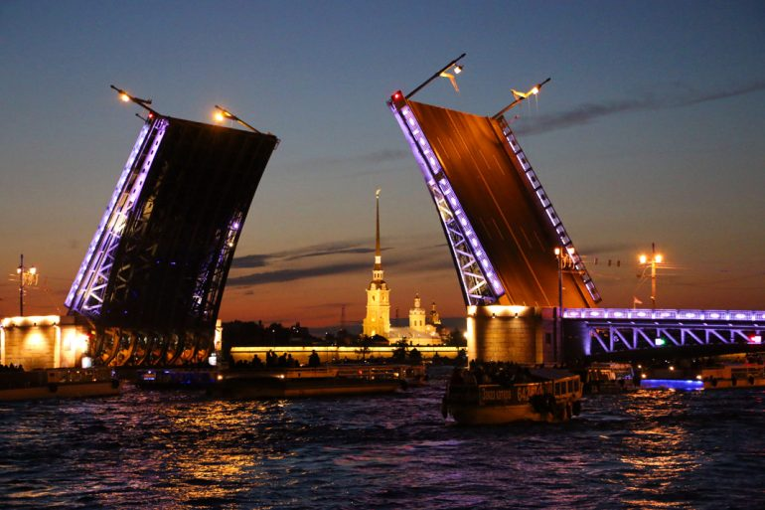
Figure 1. White nights in Saint Petersburg.
Narrow figures may be placed on the left or right side of the page and the remaining space filled with text. An example figure is given on the left. Figure caption is entered using the “Text Box” feature of MS Word.
Because the NBDC 2019 papers will be published in the USB- Proceedings, the use of color in figures and graphs is possible, and strongly encouraged. Color improves the readability of graphs and figures significantly and photographs should be named as Figures.
Figure 2. COP, Q_{o} and SMER versus drying chamber air inlet temperature for the new CO₂ heat pump dryer.
Use framed tables having both horizontal and vertical dividers. Tables should be numbered. Table captions must be typed using Arial font, 10 pt, left justified, and placed at the top of the table with spacing of 12 pt before and 6 pt after the caption.
Table 1. Dates and locations of the NDCs and NBDCs in their full and successful rotation in the Nordic Countries and Baltic region
Name | Year | Site
NDC’01 | 2001 | Trondheim, Norway
NDC’03 | 2003 | Copenhagen, Denmark
NDC’05 | 2005 | Karlstad, Sweden
NDC’09 | 2009 | Reykjavik, Iceland
NDC’11 | 2011 | Espoo, Finland
NDC’13 | 2013 | Taastrup, Denmark
NBDC’15 | 2015 | Gdańsk, Poland
NBDC’17 | 2017 | Hamburg, Germany
NBDC’19 | 2019 | Saint Petersburg, Russia

Separate the table from subsequent text by one blank line of 12 pt.

equations
All equations in the text are centered and numbered, which should appear between parentheses aligned to the right margin. Then, for equations use Cambria Math font, 14 pt, do not use bold and italic. An example of equation is:

$∆h_{s}=-\frac{R}{M_{A}}{\left[\frac{dlnφ}{d\left(1/T\right)}\right]}_{X=const}$ (1)

Equations should be quoted in the text as “Equation (#)”, where the number # is replaced by the appropriate number. Separate equation from the text with 1 blank line above and below.
A convenient way to enter equations in MS Word according to this typographical definition is using tab stops. On the horizontal ruler set a Center Tab stop at 8.5 cm and a Right Tab stop at
17 cm. To place the equation and corresponding number at the right position, use TAB at the keyboard.

TRADE NAMES, CORPORATE NAMES AND PERMISSIONS
If permission is needed to use data, figures or texts previously published elsewhere, it should be obtained by author in writing to the publisher, and, in such a case, it should be submitted with the paper.
To denote proprietary names and companies, write their names starting with a capital letter e.g. Teflon, Microsoft, Aspen, Excel, Comsol, Fluent and MatLab.

CONCLUSIONS
The papers will be published in the NBDC’s USB-Proceedings with ISBN number. By following the proposed guidelines the authors will contribute to produce USB-Proceedings with a consistent layout and superior quality.

NOTATION
International system of units (SI) is used and notation should be as proposed in the Drying Technology Journal. Example of notation is:

d density of pure component kg/m³
D mass diffusion coefficient m²/s
F mass flux kg /m²s
h convective mass transfer coefficient m/s

Greek Symbols
, β, constants -
volume fraction m³/m³
μ dynamic viscosity kg/ms
ρ mass concentration kg/m³

Subscripts
a air
b bound moisture
c capillary
eq equilibrium
g gas

Superscripts
eff effective
g gas phase
liquid phase

REFERENCES
List of references should be arranged alphabetically according to the first author. Publications of the same author(s) should be listed in order by year of appearance. If there is more than one publication for the same author with the same date, label the year by a, b, c, etc. such as (2006a). Do not number references, indent the second and further lines of each entry by 5 mm and insert a spacing of 6 pt after each reference. The example is given below:

Author(s) of the book (Year), Title of book, (Name of editor(s)), Publisher, Place of publication.
Author(s) of journal publication (Year), Title of paper, Name of journal, Volume, page numbers.
Author(s) of conference presentation (Year), Title of paper, Title of conference proceedings, Place of conference, Date of conference, Volume, page numbers.
Alves-Filho, O., Eikevik, T. and Goncharova-Alves, S. (2009), Fish protein atmospheric freeze and evaporation drying, Proceedings of the 8th World Congress of Chemical Engineering, Montreal, Quebec, Canada, 23-27 August, pp. 622-628.
Alves-Filho, O. and Roos, Y.H. (2006), Advances in multi-purpose drying operations with phase and state transitions, Drying Technology, Vol. 24(3), pp. 383-396.
Mujumdar, A.S. (1990), Handbook of industrial drying, 2nd edition, Marcel Dekker, New York.
Mujumdar, A.S. and Alves-Filho, O. (2003), Drying research-current state and future trends,
CD-ROM Proceedings of the 2nd Nordic Drying Conference (NDC’02), Copenhagen, Denmark, 25-27 June, ISBN 82-594-2550-5.

All references listed here must be cited in the text of the paper. When quoting in the text use Name, Year format, for example: (Mujumdar, 1990), (Alves-Filho and Roos, 2006), (Alves-Filho et al., 2009).

Please use the “Footnote and Endnote” feature from MS Word to enter your footnotes.

